Exercise 9 - Creating a Spring Boot Application

Name: Shubham Sangram Bej

Aim
To create a Spring Boot application for the Library Management System using Spring Web, Spring Data JPA, and H2 Database, and implement RESTful CRUD operations.

Theory
Spring Boot is an extension of the Spring Framework that simplifies the development of Java applications by providing auto-configuration, embedded servers, and starter dependencies. It reduces boilerplate configuration, allowing developers to build production-ready applications quickly.
Spring Data JPA simplifies database access by providing repository interfaces for performing CRUD operations without writing SQL queries manually.
H2 Database is a lightweight, in-memory relational database commonly used for development and testing because it requires no separate installation and integrates easily with Spring Boot.
A REST Controller exposes application functionality through HTTP endpoints using methods such as GET, POST, PUT, and DELETE, enabling CRUD operations on resources.

Software Required
- Java JDK 21
- IntelliJ IDEA
- Spring Boot
- Maven
- H2 Database
- Postman

Procedure
- Created a Spring Boot project.
- Added the required dependencies:
  - Spring Web
  - Spring Data JPA
  - H2 Database
- Configured database properties in application.properties.
- Created the Book entity class.
- Created the BookRepository interface extending JpaRepository.
- Implemented the BookService class to handle business logic.
- Developed the BookController class to expose REST endpoints.
- Executed the Spring Boot application.
- Tested all CRUD operations using Postman.

Files Created
- Book.java
- BookRepository.java
- BookService.java
- BookController.java
- Exercise9CreatingSpringBootApplication.java
- application.properties

REST Endpoints
HTTP Method | Endpoint | Description
POST | /books | Add a new book
GET | /books | Retrieve all books
GET | /books/{id} | Retrieve a book by ID
PUT | /books/{id} | Update an existing book
DELETE | /books/{id} | Delete a book

Output
- Spring Boot application started successfully.
- Embedded Tomcat server started on port 8080.
- H2 database initialised successfully.
- CRUD operations were performed successfully using Postman.
- Hibernate executed SQL queries for all database operations.

Screenshots
- Project Structure
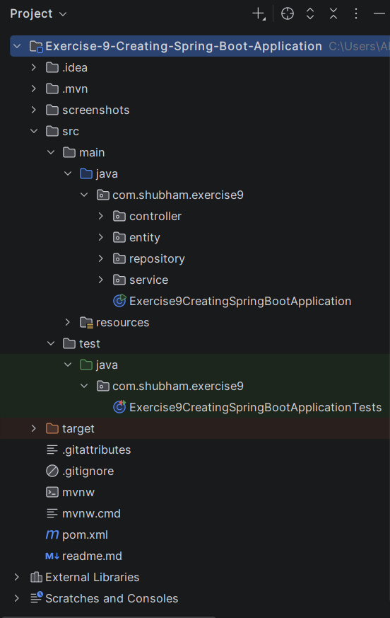

- Spring Boot Application Running
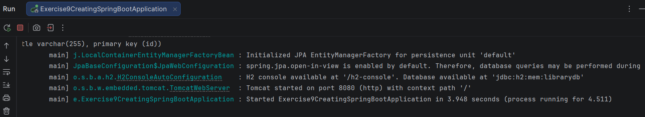

- REST API Testing using Postman
Posting Book-1:
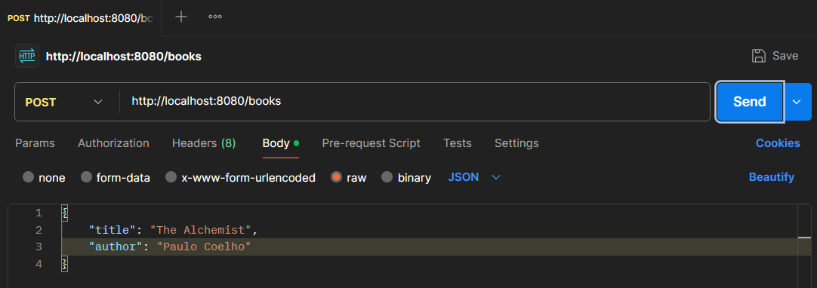
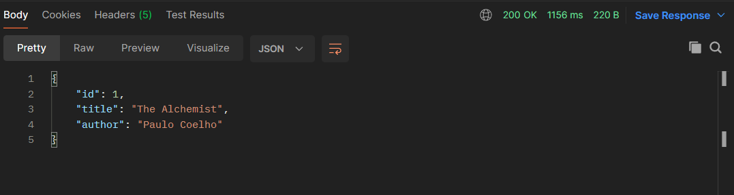

Posting Book-2:
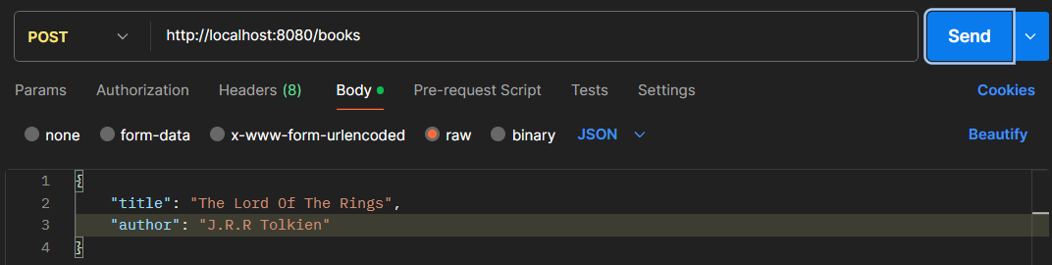
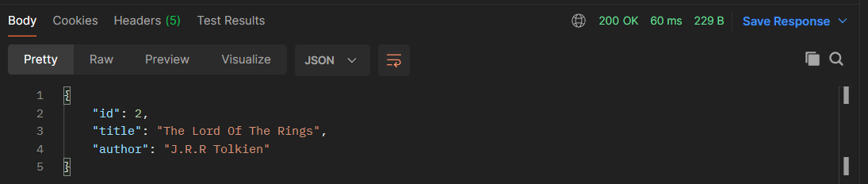

Getting all the books:
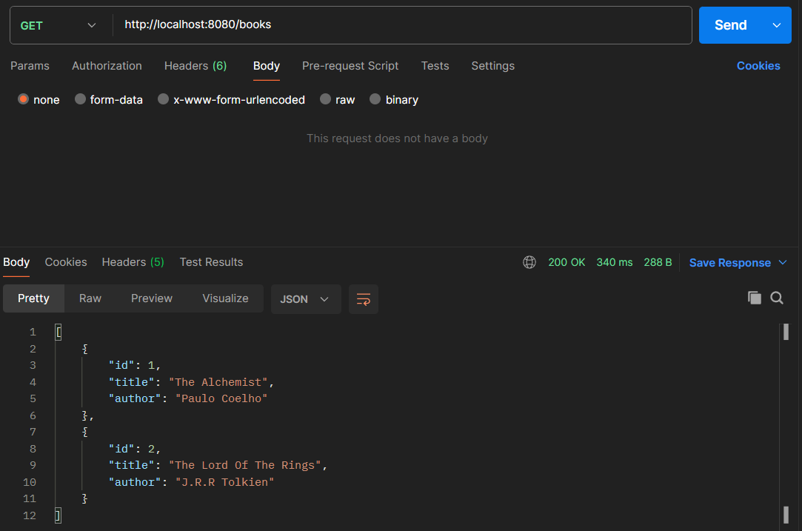

Getting Book by id:
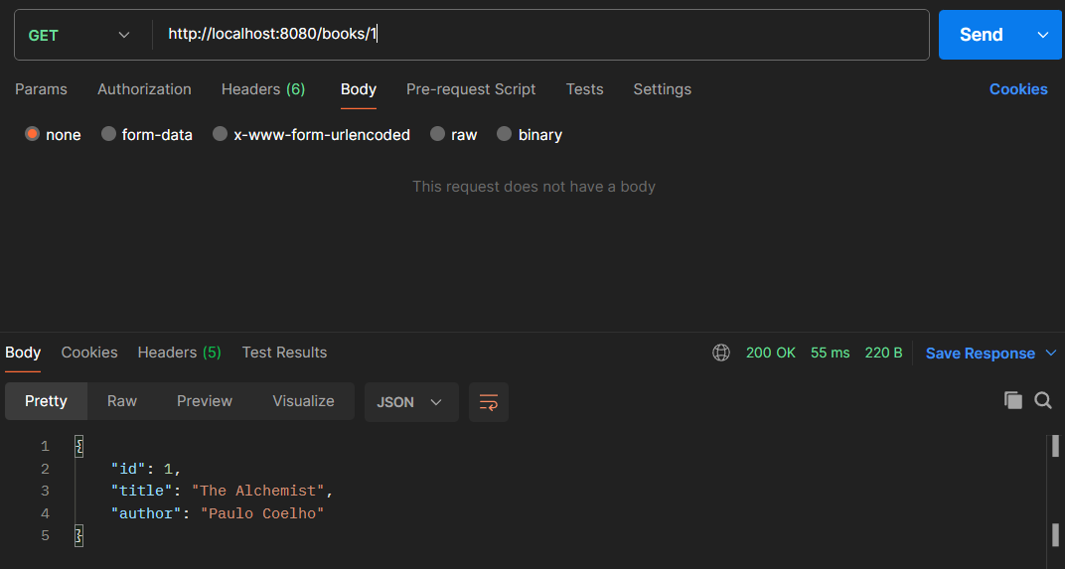
Updating a Book:
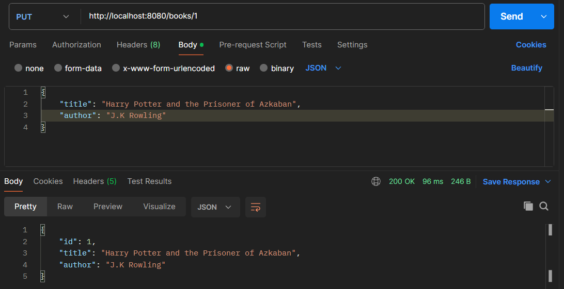

Deleting a Book:
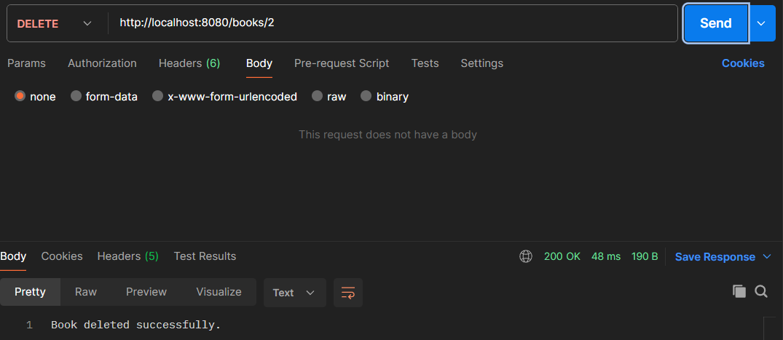

Getting all the Books after Updation and Deletion:
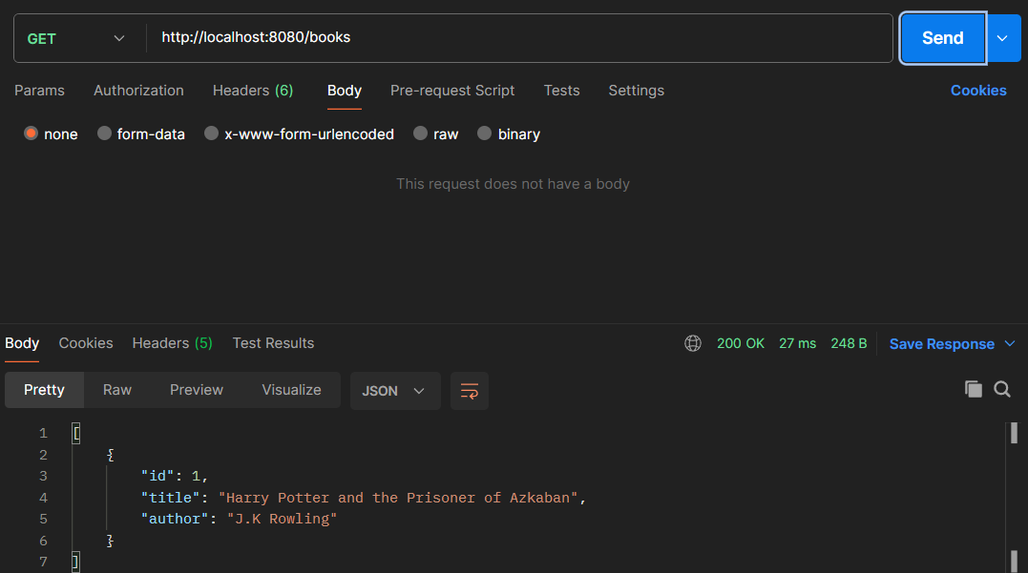

Hibernate SQL Logs:
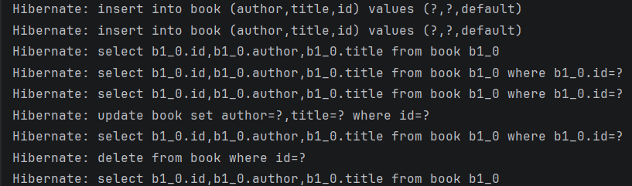

Result
Successfully developed and tested a Spring Boot-based Library Management application using Spring Web, Spring Data JPA, and H2 Database. All REST endpoints for Create, Read, Update, and Delete operations were executed successfully.

Conclusion
Successfully developed a Spring Boot-based Library Management application by integrating Spring Web, Spring Data JPA, and H2 Database. Implemented RESTful CRUD operations for managing book records and verified the application's functionality through Postman. This exercise demonstrated the ease of developing, configuring, and deploying Spring Boot applications using modern Spring technologies.

